A brief history of North American wars for the management of projects, construction, industrial and technology enterprises

Engineers were masters of projects, construction and industrial and technological enterprises in Canada and the United States up to the eighties of the last century. They were driving, and planning and control belonged to their duties. They used the services of staff to assist in dealing with costs, schedules, purchases and deliveries of equipment, materials and services. Well-guided engineers made decisions based on the principles of rationality limited, for example, by their knowledge and the ability to understand both the decision-maker and others who were affected by the decision.

They tried to minimize the administration by focusing on the effectiveness in obtaining the necessary content and quality of the projects, construction or managed companies or their departments. They made sure that the solutions were not idealized or "the best", but realistic, sufficiently satisfactory, “good enough” for specific situations concerning a given project, construction or running a specific company or its department.

The American recession of 1980 and subsequent events have begun transformation processes from the state-controlled Keynesian economy into the monetarism of the Chicago-based economics school of Milton Friedman, and the introduction of various deregulation processes. As part of aggressive financial activity, it was quickly noted that e.g. the release of x% of employees of a failing company would automatically raise on paper its productivity rate and then such even more deficient company could be sold well and quickly. It was also noticed that directing and managing engineers were lacking enthusiasm to the drive to obtain quick but often dishonest profits.

Settled for easy profit, financial directors, administrators and accountants began convincing owners to replace resisting engineers in project management, construction and management of industrial companies. With new administrative, non-engineering management, new auxiliary departments began to emerge like mushrooms after rain: planning, cost control, scheduling, procurement and services, in which rapidly developing methods and IT measures provided new ways and forms of extensive, elaborate control and resulting rapidly growing documentation.

The new emphasis on financing, planning, and scheduling, promoted further formalization of projest activities and documentation, which resulted in a significant increase in organizational efforts leading to an increase in the complexity of projects and increased employment of support staff. An additional effect was also the extension to private companies, previously existing mainly in public enterprises, depersonification phenomena, i.e. suppression of the influence of individual and personal characteristics of personnel by requiring a unified behavior in accordance with the increasing regulations, procedures and standards.

The result of these processes was increasing costs and extending the time of implementation, thus reducing the efficiency of projects and construction, as well as often accompanying reduction of quality and deterioration of the general functioning especially of larger organizations. In the face of these phenomena, organizations have been intensively adding efforts to improve projects, construction and enterprises.

This self-propelling process kept replacing the knowledge and many years of experience of professionals with growing sets of standardized procedures. These standards were intended to allow for cheaper and easier available workforce.

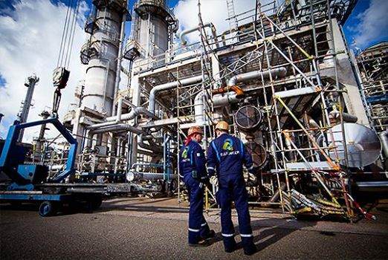

What happened with the replaced managing engineers? Some moved back to non-management positions, some got out of engineering, other joined new project managers. The last category have settled as one of two sub-categories as follows. One sub-category, where I belong, are ones who, sometime risking their careers, try to maintain quality of engineering work and would e.g. resist undue cutting engineering budgets and exclusion of engineers early on the projects. The other sub-category are those yielding to the administrative control that may include the opposite e.g. excluding engineers from the front end of the project and cutting engineering budgets.

The governments generally support the artificial inflating of prices and costs of projects because it improves GDP, gives employment, and makes even absurd but politycally convenient projects and energies vialble to offer and implement. The engineers are silent because some of their leaders have changed their profession, other have been demoted, let go or surrendered to the bureaucratic will, and still anothers may have been always interested more in the matters of dead things rather than in the affairs of people.

What engineer can do now? Emboldened by the Internet, the engineer can discover more and more previously inaccessible information, questioning the impunity of decision-makers and credibility of authorities and playing a stronger role in society; to go beyond the traditional position of a technical adviser whose advice may or may not have been used. Today the engineer can use his knowledge and skills to effectively formulate positive pressure starting from a deeper understanding and breaking through the thicket of more or less real complexities often mixed up with unnecessary complications created by man.

The engineer can become, if not the initiator, certainly a more active participant in changes not only in technology, but also in everything that surrounds it. The areas of the technology environment discussed here are: a controversial subject of innovation (bottom up from a garage or top down from the bureaucrats), a science containing both research and education, business and management. Engineers can also start to revive their associations.

The title of 'engineer' in this article applies also to self-taught people with knowhow and experience often greater than those with diplomas, and it generally does not apply to engineers possessing engineering papers but not practicing engineering (e.g. those who were approving windmills, knowing that winds in Ontario blow mainly at nights).

